If you have concerns that a child is suffering or at risk of significant harm – please contact:  Call Derbyshire on:  01629 533190  Or contact the police by calling their call centre number:  101  If a child is at serious  (immediate) risk of harm do not hesitate to contact the  Police on 999!! | The most valued resource we have is each other  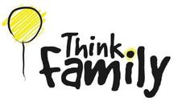  To secure the best possible outcomes for children and families we would highly recommend that you seek support from your school/nursery, local health services and the Early Help Transition Team. A support network is available to you, we would encourage that a Think Family Approach. Family is always at the centre of all Early Help work. | 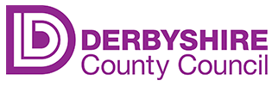  Amber Valley  Early Help Transition  Team  Stronger families safer children  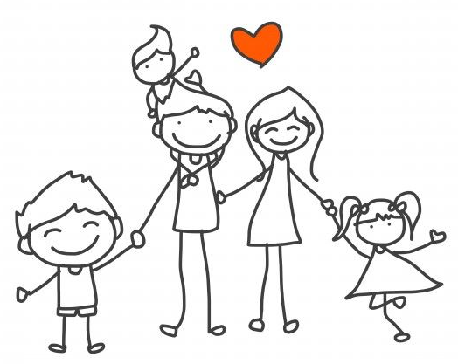  A helping hand for the whole family  The right help, at the right time, by the right service
Early Help Transition Team  The county transition team are here to support schools and partner agencies to develop and maintain their own early offer and early intervention support for children and families.  Our skilled Early Help Advisors work directly with partners including schools, GPs, Voluntary, community and independent sectors to provide:  Information advice and sign posting  Support, mentoring and training around Early Help Assessment and Team Around the Family Meetings (TAF)  Advice on practice and early help approaches  Support connections to appropriate community services  Provide some workforce development through role modelling (Briefing sessions)  Host Professional Peer support meetings and Partnership meetings | Each school in Amber Valley has an allocated Early help advisor.  Our Youth and Community Engagement Workers will focus on providing support for voluntary organisations. They will support communities to thrive and deliver local groups for parents and young people.  They have developed the community directory, which details community support available to everyone.  https://www.derbyshire.gov.uk/social-health/children-and-families/support-for-families/community-directory/community-directory-for-families.aspx  The Employment and Education Team provide support to young people 16-18 years to connect them to appropriate employment, education and training opportunities and the employment and education offices, will contact young people to find out whether they are in education or not.  Partner agencies can access Early help advice, support and guidance by contacting the Early Help Transition Team. Our advisors can assist you by offering advice via; telephone, email, Teams call and face-to-face.
Contact information for Amber Valley
Early Help Advisors:
Penny Parker
penny.parker@derbyshire.gov.uk
07789508714
(Monday-Friday)

Sarah Robb
Sarah.robb@derbyshire.gov.uk
07812772558
(Monday to Friday)

Lesley Whetton
Lesley.whetton@derbyshire.,gov.uk
07805803751
(Monday and Tuesday)

Youth and Community Engagement Worker
Mikey Heald
Mikey.heald@derbyshire.go.uk

Employment and Education Team
Susan Richards
Susan.richards@derbyshire.gov.uk
Irene Wells
Irene.well@derbyshire.gov.uk

